**SSD Samsung Brand**

PKR 2,500 Pro

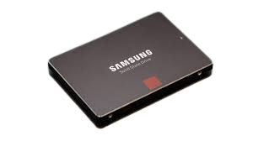

A solid-state drive (SSD) is a new generation of storage device used in computers. SSDs use flash-based memory, which is much faster than a traditional mechanical hard disk. Upgrading to an SSD is one of the best ways to speed up your computer. Learn how SSDs work and how to keep them optimized with a specialized performance-boosting tool.SSD adoption began in high-performance technology areas and in enthusiasts’ PCs, where the drives’ extremely low access times and high throughput justified the higher cost..

**Type: Internal**

**Size: 4.5"**

**Speed: 17000rpm**

**Species: 150GB**

**Brand Name : Samsung**

**Application: Server**

**Cache capacity: SSD**

**Item Condition: Fresh/New**

**Shell Material:** Metal

**Products Status :** Good New